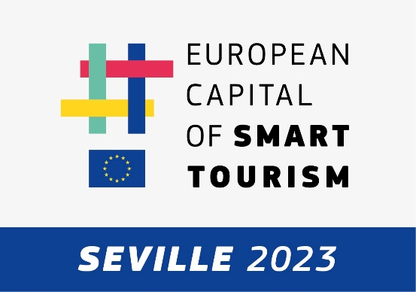

Sevilla City Office has created the Smart Tourism Office, a pioneering initiative in smart tourism. The Smart Tourism Office is the department where the vision of Seville as a shared city is researched, innovated, and created, putting the quality of life of residents at the center and working to build a sustainable tourism model. This new vision of the Smart Tourism Office understands tourism from a model of sustainability where there is the necessary and positive coexistence between citizens and visitors.
Among the projects developed by the Smart Tourism Office is the creation of a Sustainable Urban Laboratory that seeks to provide answers to Seville's tourism challenges. This laboratory is organized around missions in which private companies and other public administrations participate to find a joint solution.
The first of the proposed challenges revolves around the decongestion of tourism in the historic center of the city, where the main heritage and cultural resources of Seville are concentrated. The impact of the visitor in the neighborhood has negative effects on the coexistence with the resident and that is why the Smart Tourism Office is developing a project that consists of decongesting and diversifying tourist flows to other parts of the city, causing not only the improvement of the quality of life of the neighbors, but also improving the experience of visitors, who can discover the "Seville more unknown" to enjoy the "Seville more famous" with more peace of mind.
The project does not consider 100% of the Santa Cruz neighborhood, but establishes a specific pilot in the area contemplated between the following streets of the central neighborhood:
- Plaza del Triunfo
- Joaquín Romero Murube
- Plaza de Doña Elvira
- Calle Vida
- Calle Agua
- Plaza Alfaro
- Plaza de los Refinadores
- Calle Santa María la Blanca
- Calle Fabiola
- Calle Mateos Gago

The project is structured in three phases:

Measurement and observation phase.
In this first phase, the aim is to measure those data that are relevant for the analysis. Therefore, we will try to have as much knowledge as possible about the field of action and especially those factors that directly affect the object of study.
There are a total of 10 points where two types of sensors will be installed in bloc: Wi-Fi Location and Presence Analytics sensors and optical sensors; which will allow us to have real-time data on the capacity, affluence and flow of visitors in the area. The installation of the two technologies together in the same block will allow us to have more knowledge about how these technologies are able to provide quality data and we can extrapolate this knowledge to other areas of the city. It is understood that both technologies will provide quality data when they are able to have a similar behavior and correspond to reality, after processing for acquisition.
In addition to the sensors, data from telephone operators will be considered, which will allow us to have more information and make a weighting of the number of visitors in the area versus residents.
These other factors are measured, observed, and analyzed to provide as much information as possible for the second phase.

Prototyping phase.
All the extracted information is treated and analyzed from different fields. For this project we will have the participation of the University of Seville and a technical committee formed by the collaborating companies within the Sustainable Urban Laboratory in which technicians from other areas of the City of Seville participate.
For all participants to speak the same interpretation of the data, a digital twin has been developed in which the different data sources are incorporated.

The Smart Tourism Office will be responsible for coordinating the technical teams designated to process and analyze the information and build and design the prototype solutions to be incorporated in the implementation phase.

Phase of implementation of possible solutions.
Once the possible solutions have been analyzed, the stage of implementation and feedback of the implemented solution begins, that is, when the actions are considered appropriate, we will proceed to impact in some way on the activity and the course of the neighborhood from different areas, establishing indicators and tools to assess the effectiveness of the same.
These solutions will be undertaken from different areas: from the side of the supply of resources to the visitor in the other poles and from the side of the demand for consumption of these resources by visitors. A priori there are a multitude of actions, technological or not, that can be recurrent to provide answers to certain questions that arise once the data have been exploited and the information extracted.

